The Waymarker

June 2022 Dover & Thanet Rights of Way Society

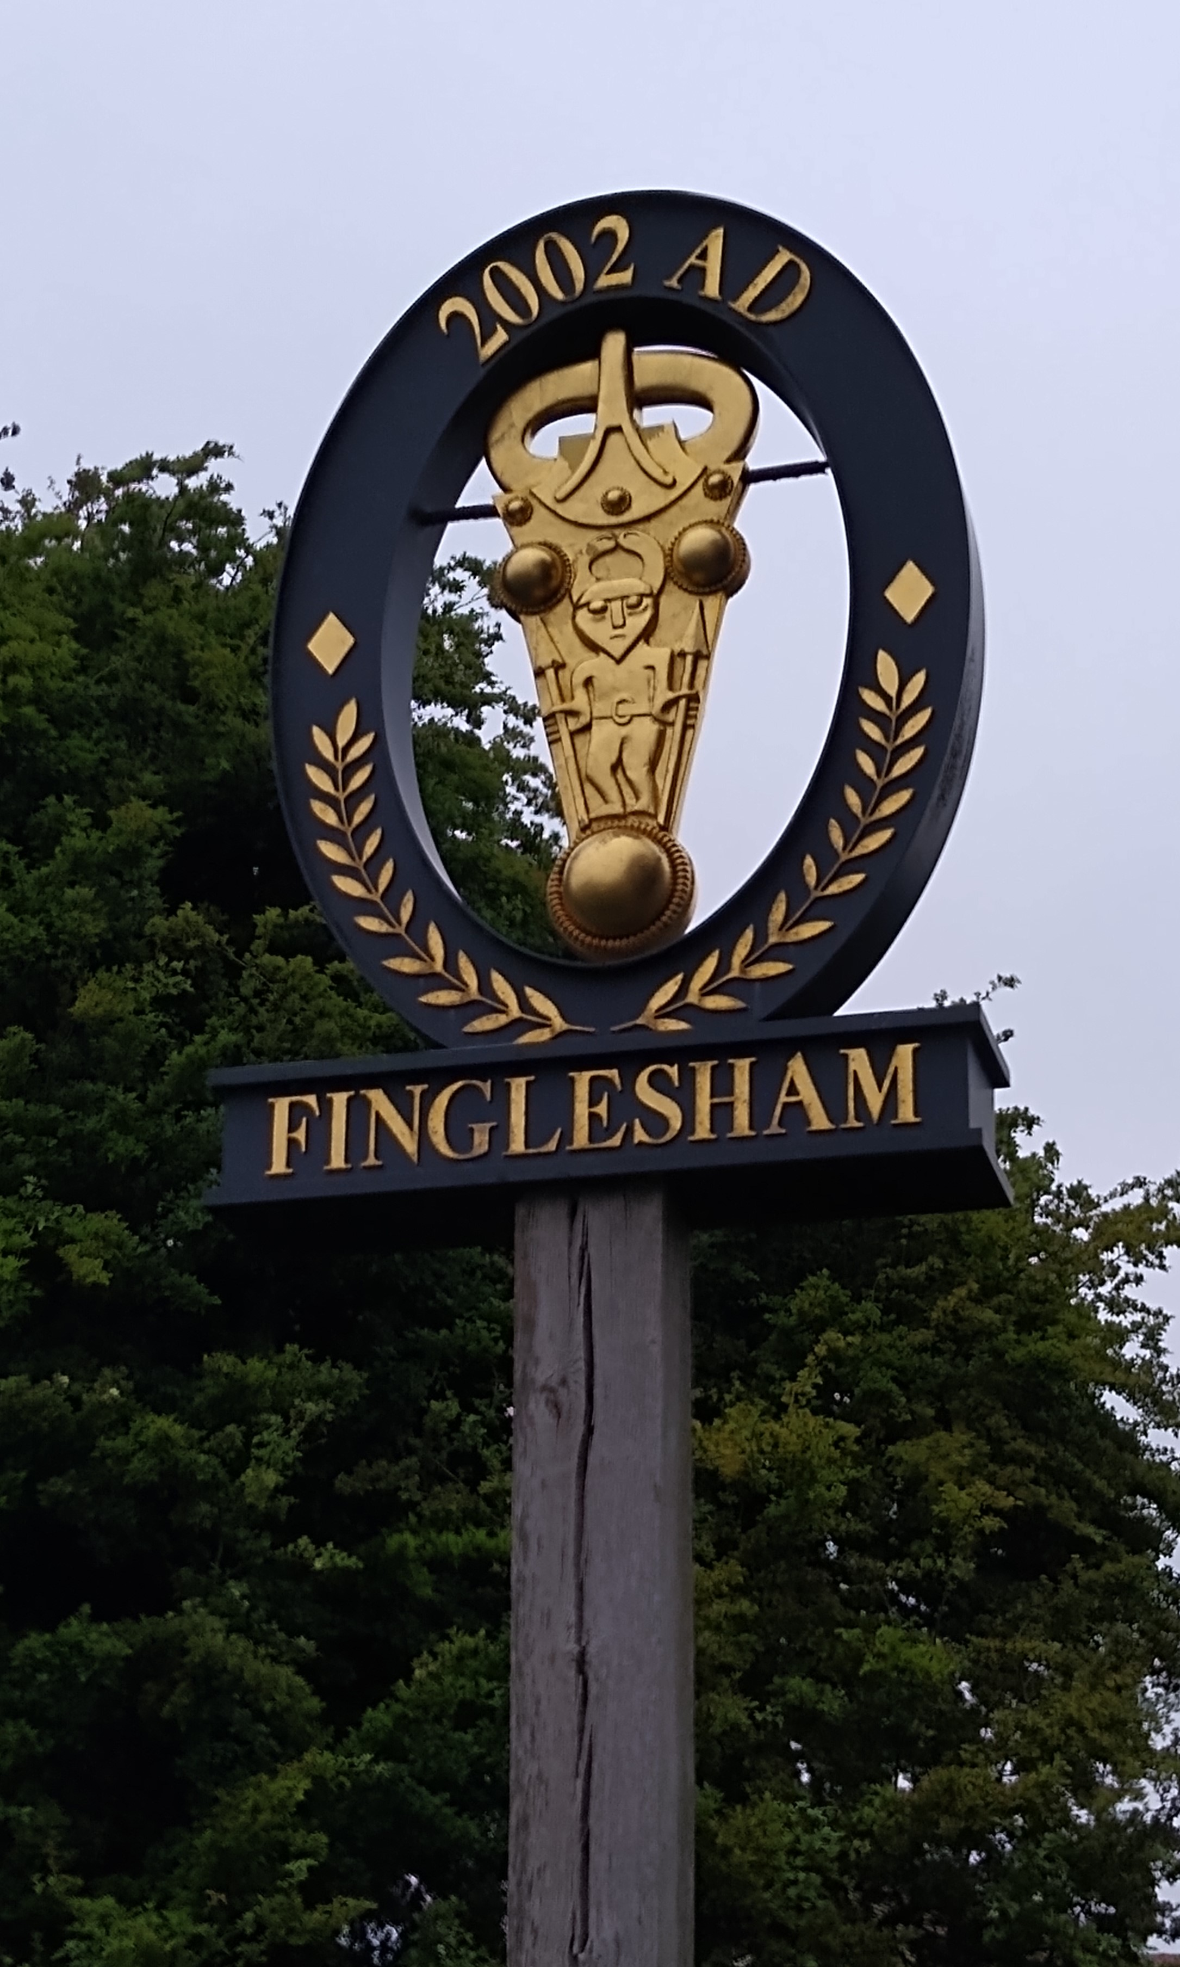

Chairman’s Report
One thing that astounds me is the openness and friendliness of DATROWS as a walking group. It is a joy to join you on Sundays.
I am proud to say that thanks to Steve and Jan we have run a full walks programme, not only this year but also through the lockdown restrictions, where permitted. A thank you goes to the walk leaders especially the new ones, as leaders are the life blood of the society.
Particular thanks also go to Mike and Angela for arranging our finances and membership which is creeping up to the hundred mark.
At our AGM, Roger talked on PROW activities, the number of outstanding tasks and that they are now focussing on public footpath clearance to help clear the backlog rather than their enforcement activities. Jerry
Membership Secretary’s Report
We in DATROWS do love our walking! I can report that membership numbers remain good. Going by the numbers who turn up for the walks it’s obvious that we are keen and energetic even if some of us are getting on a bit!
Just a gentle reminder …... if you have forgotten to pay your £5- annual household membership sub for this year, then please do forward it to myself or the treasurer, Mike.
I am very pleased with the interest shown in the holiday to The Isle of Wight this year. We are going to a Warner’s Holiday Hotel again. It is going to be at their Bembridge Coast Hotel on the East side of the island. We are going to be a group of 19.

I have booked a combination of Double chalets, Twin chalets, and single occupancy chalets and rooms. The price includes the ferry crossing and parking of a car at the hotel. If you are travelling with others in their car, then of course you pay a lesser price. The balance is due to be paid by July 11th and I will send out reminders before then. We will once again arrange our own walks. There will be longer or shorter routes planned so that everyone is suited. We will meet in September to discuss details.
Angela
Treasurer’s report
For those of you who were unable to attend our face-to-face AGM in March and therefore did not see the Society’s accounts please be informed that your society’s accounts are healthy and at the end of the financial year (28th February) money in the account totalled £2,944.10p up £17.23 from last year. As I stated last year because of the withdrawal of insurance cover for clubs by HF Holidays insurance company we had to source our own insurance which we did with Protectivity Insurance at a favourable yearly rate of £70 with a £2 million public liability. This has remained the same this year. If any member wishes to see the accounts for the end of the financial year February 28th, 2022, as presented at the AGM just email me, and I will email you a copy.
Members are once again advised that the Society belongs to the Walking Partnership, supported by Ramblers Worldwide Holidays. This partnership earns us money when any member who books a holiday with Ramblers Worldwide Holidays quotes our Society’s name.
Mike
Walk Secretary’s Report
2022 got off to a flying start, with several new members joining and new walk leaders introducing us to new places. It wasn’t unusual to have more than 20 people on a walk, with an average of 18 people on the Saturday walks, and 17 on the standard and leisurely walks.
Several members have said how much they enjoyed the ‘Women of Canterbury’ walk led by Jan on 6th March, although it was a bit chilly! The walks programme for the second half of the year will be coming out with the June edition of Waymarker, and we look forward to seeing as many of you as possible out in our marvellous countryside. Once again many, many thanks to our walk’s leaders – as Bob said it’s great that you want to share your love of the countryside with the rest of us.
Jan & Steve

Annual General Meeting
The AGM was held at the modern spacious village hall at Woodnesborough on 25 March. It was the first time for two years that members had been able to meet in person. It is such a joy that we can now walk and meet without government restrictions. The Chairman, Jerry Swallow said that the walks had been continued with a 'light touch' during restrictions and thanked Jan & Steve saying they were the 'life blood' of the group. After the other reports the Committee was re-elected en bloc. A talk on re-wilding in Kent was given by a representative of Kent Wildlife Trust before a generous buffet provided by members was enjoyed by all.

Monika and Darrell Memorial Walk from Worth on Sunday, 12th June 2022
The walk was arranged to commemorate Monika & Darrell who both died recently within a few weeks of each other. Monika and Darrell joined DATROWS in August 2001 and were keen walkers, Darrell leading hikes in the area where they lived round Woodnesborough, sharing his time on a Sunday morning as a bellringer in his local church.

It was Monika who started Club holidays, arranging two trips to Germany, her home country where her mother lived. Incidentally, it was as a result of these holidays that Barbara and Paul got together. They are sorry they can’t join us today as they are in Bulgaria. Robin Wickenden was on these holidays with his brother-in-law who also sends his regrets that he can’t join us.

These organised trips were followed by other holidays led by club members including to the Loire Valley in France with Serge and Helen, Crete organised by Audrey and an HF holiday to Church Stretton organised by Walter and Valerie, followed by a holiday in Haytor, Devon. These were in addition to the annual day trip to France arranged by Keith.

This tradition of group holidays has now been taken on by Angela, for which we are very grateful. The fourth of these holidays will take place in Warner’s, Bembridge on the IOW in October this year. So, you see, Monika and Darrell started a great tradition for the Club. Long may it continue! About 24 members gathered for the walk from and most of them shared memories of Monika & Darrell in the sunny garden of St. Crispin inn and raised a glass to them before they left. Anne

LOCAL RIGHTS OF WAY NEWS from Roger

KCC General News: At last, the Ramblers Local FP Officers were able to resume their twice-yearly meetings with KCC in March. The information provided about 22/23 was largely positive. They now have a full complement of staff at Brabourne and an adequate budget after the pressures of last year with so much COVID recovery cash to spend and not enough officers to make best use of it! This had led to their concentrating more on improvement “works” like resurfacings, and less emphasis on the bread and butter reports we tend to make (crop and other obstructions, vegetation etc.).

This does mean that with 3,602 issues reported in east Kent in 2021 but only 2,710 resolved, the backlog is now of the order of 5,000. Hence the number of reports we make which may remain “not allocated”, although it is vital that we still do record them at https://webapps.kent.gov.uk/countrysideaccesscams/standardmap.aspx The largest single category was vegetation problems, so it’s a good thing that KCC are confident about their clearance contact for this summer, and it does seem to have got off to a good start. But still just as well that we have our excellent Ramblers White Cliffs team, whose good works are publicised on their Facebook pages!

Happily, communication with KCC has improved somewhat after my complaints last year. And we in Dover and Thanet can be grateful to have the industrious and conscientious KCC Officer Heather Waller covering our area. She is so helpful.

Guston Inland Border Facility: Despite the further postponement of post-BREXIT import checks, work has begun on the smaller site, with a small temporary diversion of the NDW pending the possibility of something more permanent. Construction of the Dover Fastrack Road in the same area has also begun. This will eventually provide for a new bridge crossing of the A2 close to Tesco – for use by buses, bikes, and pedestrians, but not private cars.
Little Mongeham Airfield Proposal: Delayed by the need for further consultation due to an admin mix-up, so still not timetabled to go before Dover DC Planning Committee. Local opposition remains strong.

Removal of the 2026 deadline for claiming new rights of way I’m sure you will have all seen that the cut-off date of 1/1/26 for submitting claims for new rights of way based on historical evidence (as opposed to user evidence) has been removed. Something Ramblers have been lobbying for and really good news.
Path change news - a really busy time, so just the Highlights”

Orders made to create new restricted byways from How Bridge, Finglesham to Hacklinge pumping station EE494 (Northbourne parish) would run from How Bridge at Finglesham (GR 342 538) north alongside the watercourse to join with footpath EE365 (which would be upgraded); then along that path through to the Coach & Horses on the main A258. EE495 (Sholden parish) would then continue along the well-used track opposite the pub, all the way across the marsh to the pumping station at GR 349 550. Here there would be a connection with bridleway EE233 onwards along the track towards Blue Pigeons Farm at Worth. A valuable addition to the PROW network.

Creation of new restricted byway Eastry EE493. Now confirmed, this new restricted byway of approx.0.6 miles runs from Northbourne Road by Updown Lodge (GR 313 537) south-south-west to the Straight Mile at GR 309 529 (just east of the A256). Most of the route is already walkable.
Creation of new bridleway: Eastry EE490. Confirmed by the Planning Inspectorate, this new 200-yard bridleway runs from Monkeys Hill (Middle Heronden Farm) at GR 298 541 south-east to Thornton Lane, SW of the main village. Here it connects with new bridleway EE491, created last year, which further east joins bridleway EE488, itself created in 2020, to provide a lengthy equestrian route terminating at the main A256.
Swingfield bridleway HE181 diverted
A long diversion of the bridleway which previously left the Lydden to Swingfield road near the Commandery and passed through the outbuildings of busy St John's Farm. The new route leaves the road further west at GR 230 440 and runs on a straight-line route effectively all the way south to Swingfield church.

Further diversion of Shepherdswell footpath ER81 likely
With the approval of new houses immediately south-west of the Village Hall (DOV/20/01508), ER81 will have to be diverted around the south-west and south-east boundaries of the site. This is ironic, as the path will be partly put back onto the route which we fought to keep in 2017. But of course, the rural nature of that original route will have gone by then.

Order made to upgrade Sutton footpath EE427 to bridleway status On appeal, KCC were instructed to make an order to upgrade this footpath. It runs from just SW of Sutton village through to the Ripple-Martin Road near Winkland Oaks at GR 342 482.
Ripple footpath EE451(Hangman’s Lane) – upgrading to bridleway status to be decided at Public Hearing. Just beyond footpath EE427 lies EE451, which runs from the Ripple-Martin road via the Hangman’s Lane track and across the railway to Ringwould Road, SW of Ringwould village at GR 352 479. Our 2020 objections were withdrawn after KCC advice that (perversely) grounds of safety and partial destruction of an historic green lane were irrelevant under the law which specifies precisely what an Inspector is allowed to consider. However, other objections have not been withdrawn, so the Planning Inspectorate will hold a Public Hearing on a date to be announced.
Creation of new Coldblow Woods footpaths to be decided by Public Enquiry
Since the order to create new Ripple footpath EE489 was objected to in 2020, this long-running saga will be decided at a Public Enquiry – to be held at Deal Town Hall on 11 October. If confirmed, the order would create a new footpath inside the NE, SE and NW edges of the Woods, situated between Walmer station and Ripple Mill.

What’s in a name (2): Thanet
The earliest surviving texts that refer to Thanet are in two forms – Roman with Greek antecedence, and early churchmen. Here’s a brief note on sources:
The Alexandrian Ptolemy (c100-170AD) gathered all the geographic knowledge of the Graeco-Roman world into his Geographia (AD141-150). Book 2 identifies the location of towns of the Cantii tribe as being Londinium (London), Daruernum (Canterbury), and Rutupiae (Richborough). Rutupiae (variously spelt) was the main harbour for entry into Roman Britain and seems to be mentioned more in Roman literature than other places in Britain, both by poets (Britain was ‘the Rutupine shores’ of Lucan) and in historical prose. Gaius Julius Solinus in The Wonders of the World (mid third century AD) is the first Roman writer mentioning Thanet as such, calling it ‘Athanaton’ and ‘Thanaton’. However, Hasted (1800 edition) tells us that the Saxons called it ‘Teneth’ or ‘Tenetlonde’.

Unlike the Geographia earlier Roman writers follow Caesar’s Gallic Wars (58-52 BC) in that they’re more about the politics of Rome, being written for a Roman audience - either to claim martial worthiness, to vilify opponents as barbarians who required civilising by Rome, or to praise the locals as noble and free of the tyranny of despotic rule of the Caesars. There is little of the lives of people from East Kent, except statements that identify tribal groups to support Roman political ends, though substantial inferences are made in later commentaries to build a story of English antecedence – especially in the historical embroidery of the Victorian period.

The church histories also indicate that theirs is a civilising aim – substituting the word ‘heathen’ for ‘barbarian’ when describing their opponents. Bede’s Ecclesiastical History (completed 731AD) names the Isle of Thanet as having 600 families (‘according to the English way of reckoning’, not the church’s way) and being divided from the mainland by the Wantsum River (Vaxtsumus) which was crossable in two places. Bede also notes that the Thanet soil is remarkably fruitful.

Before the age of Chaucer and mechanised printing spelling was more imaginative than consistent. Thus, in pre-conquest texts Thanet also appears as Thanet (675AD), Tenid (679AD), Thaneto (694AD), Taneti (696AD), Tanatos (by Bede c750), Tenyt (944AD) and now for something completely different, Ruim, a supposedly Celtic name according to much later sources.
This latter spelling, Ruim, is in Bishop Asser’s Life and Times of Alfred the Great (c974 AD). Unlike the more measured Bede, Asser’s writing reads like a thriller in the translation I have. He writes of ‘the heathen (aka Scandinavian raiders, Viking) wintered in the Isle of Thanet’ and after taking payment for a truce ‘after the manner of foxes, (they) burst forth with all secrecy from their camp by night, and setting at naught their engagements, and spurning the promised money—which they knew was less than they could get by plunder—they ravaged all the eastern coast of Kent.’ Steve

EDITOR’S JOTTINGS
As I can no longer join you for the walks, I would appreciate a 'roving reporter' to tell me of any interesting happenings on the walks. It need not be a full written report, (although that would be appreciated) just a phone call or a quick e mail would help me to add interest to the Waymarker. Press date for next issue – Mid November
Linda

